bi_tv_imdb_genres & bi_top1k_imdb_genres 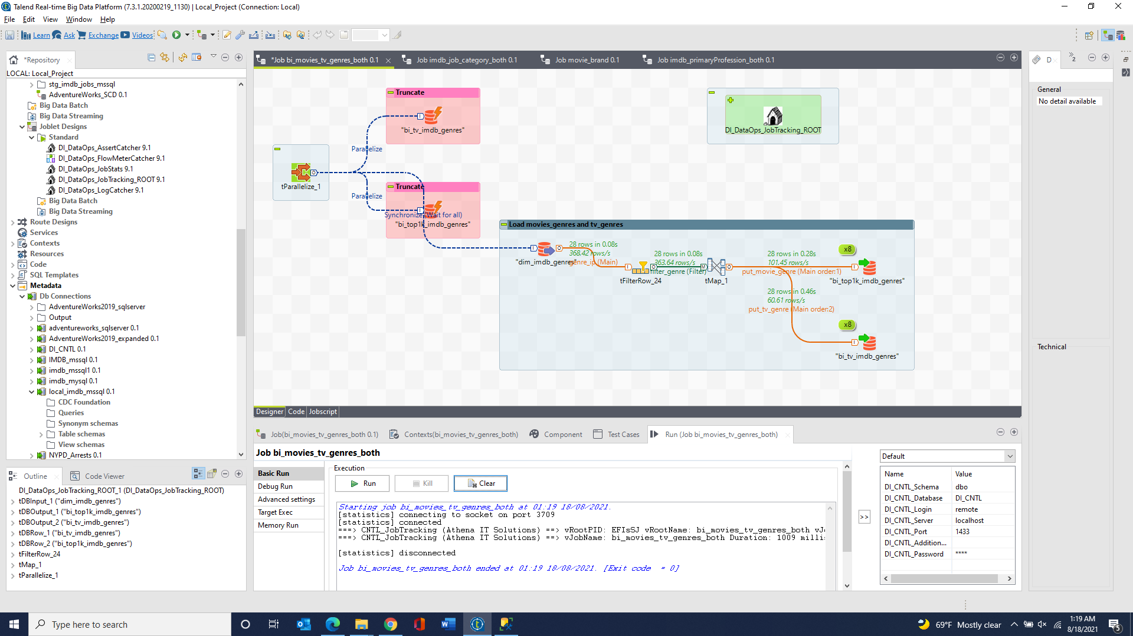

bi_tv_imdb_job_category & bi_top1k_imdb_job_category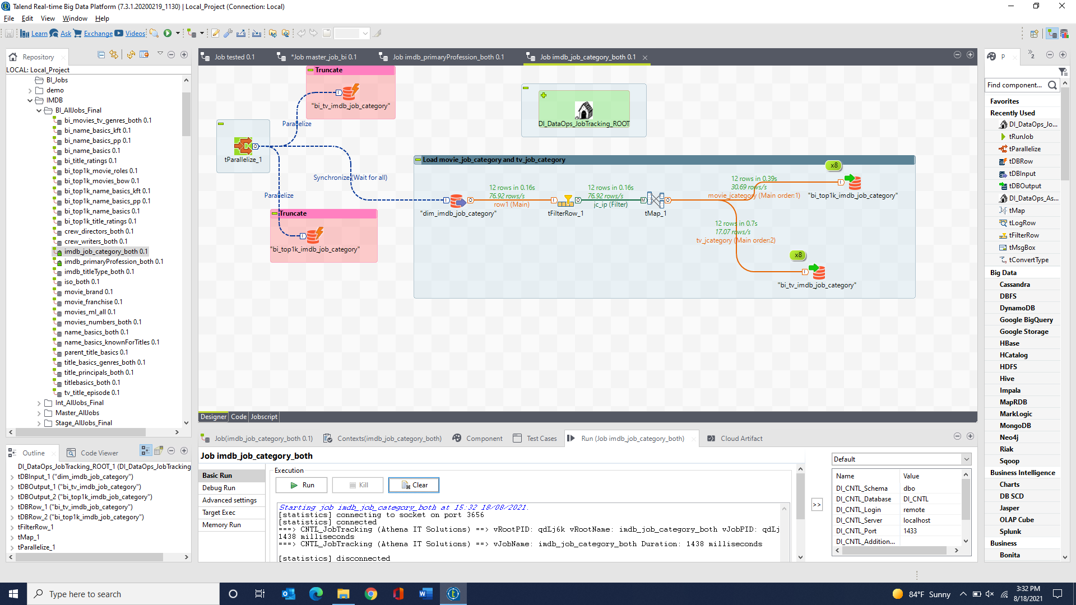

bi_tv_imdb_primaryProfession & bi_top1k_imdb_primaryProfession 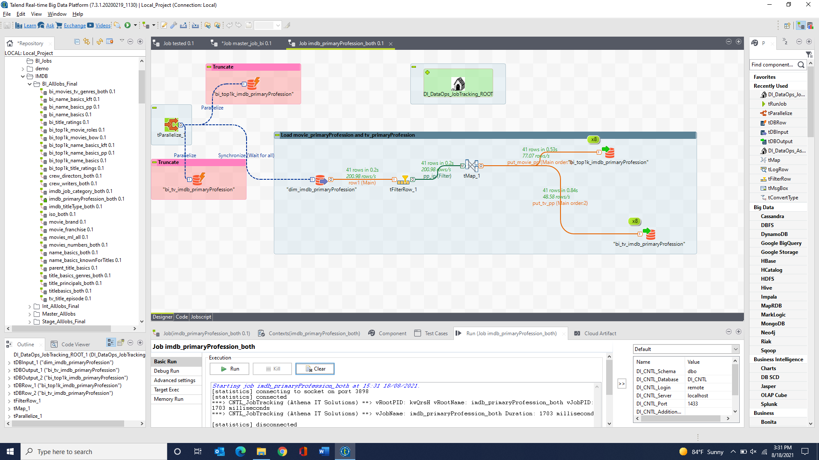

bi_tv_imdb_titleType & bi_top1k_imdb_titleType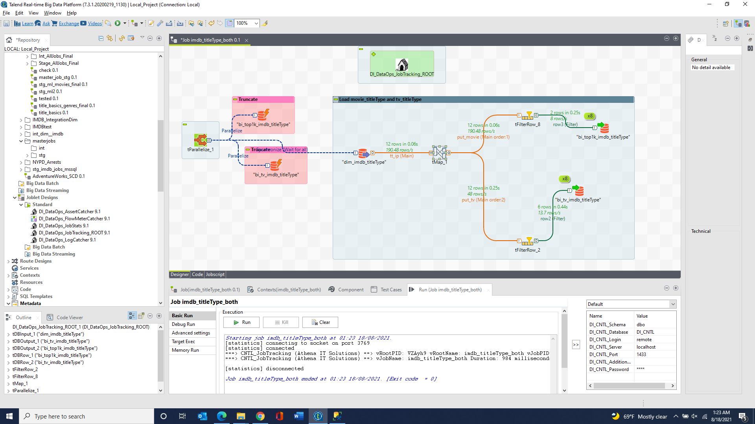

bi_tv_iso_country & bi_tv_iso_language & bi_top1k_iso_country & bi_top1k_iso_language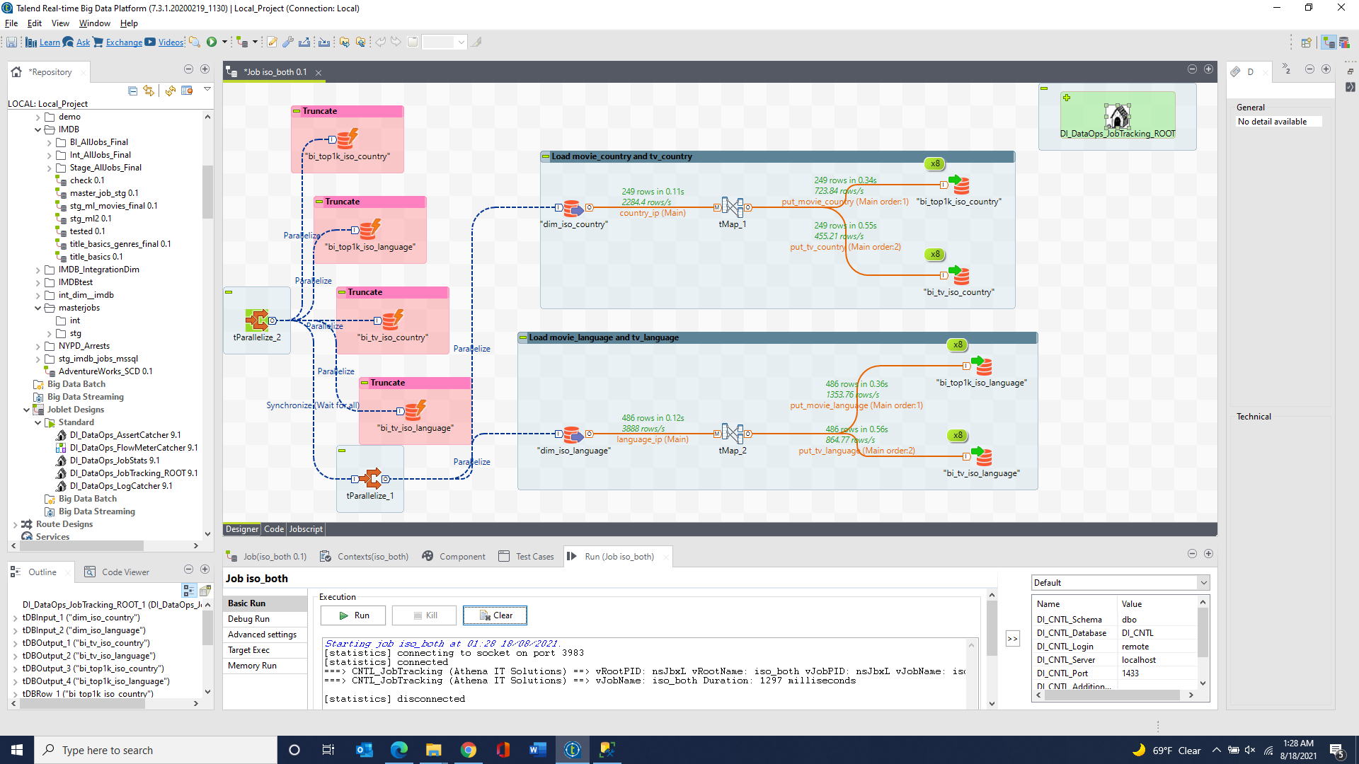

bi_tv_imdb_title_basics & bi_top1k_imdb_title_basics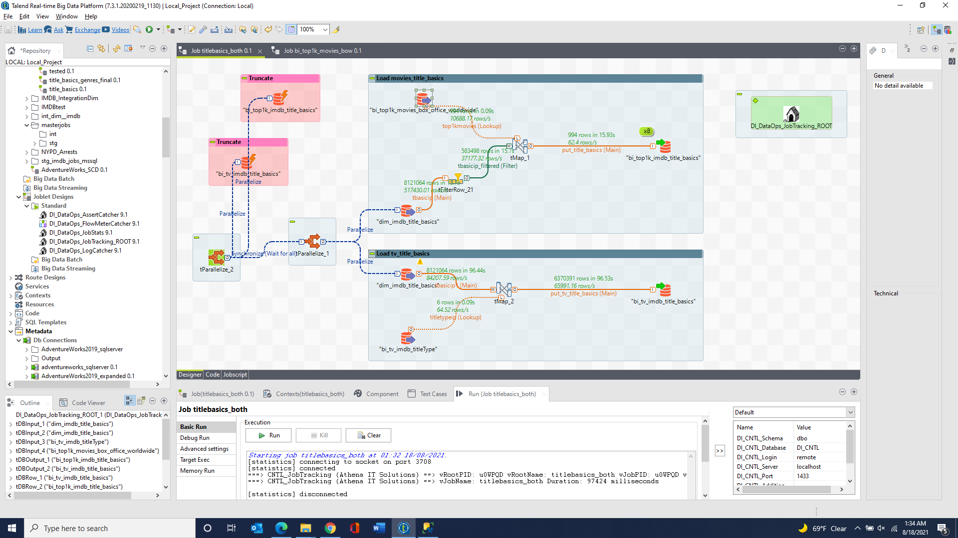

bi_tv_imdb_title_basics_genres & bi_top1k_imdb_title_basics_genres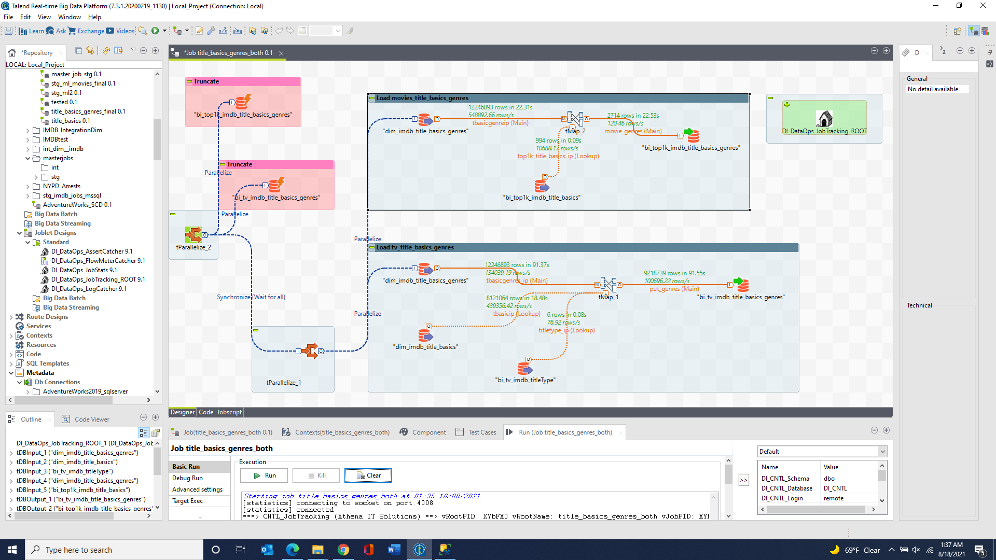

bi_tv_imdb_title_ratings 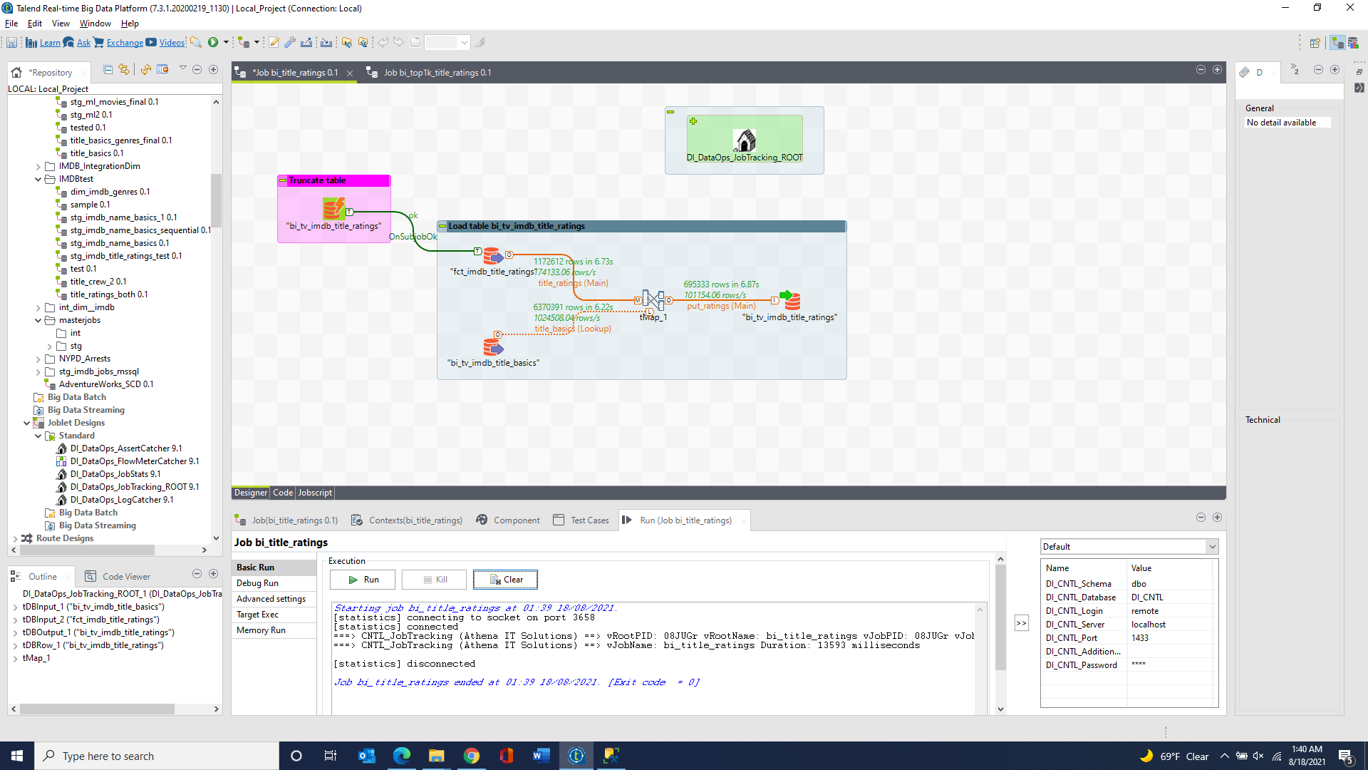

bi_tv_imdb_title_crew_directors & bi_top1k_imdb_title_crew_directors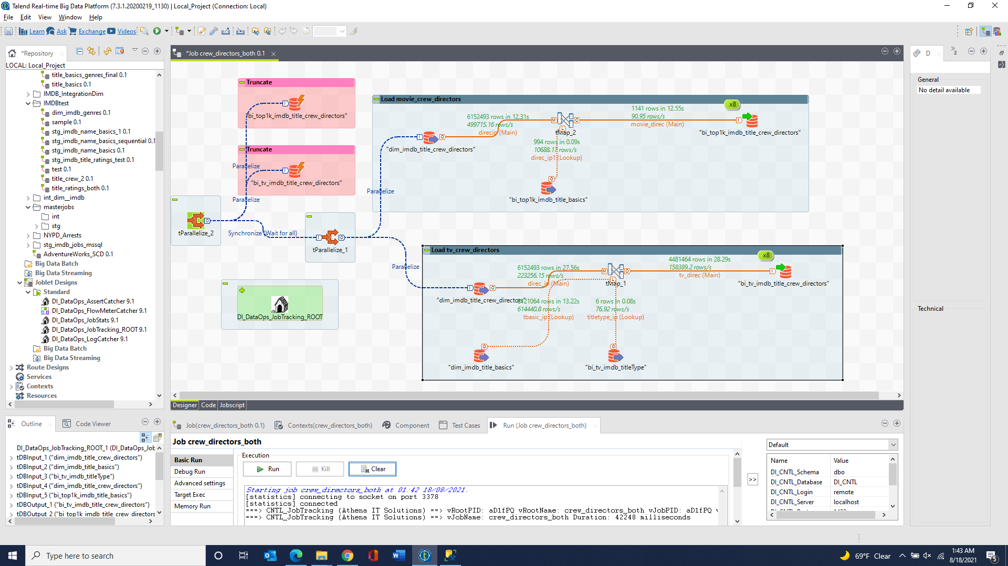

bi_tv_imdb_title_crew_writers & bi_top1k_imdb_title_crew_writers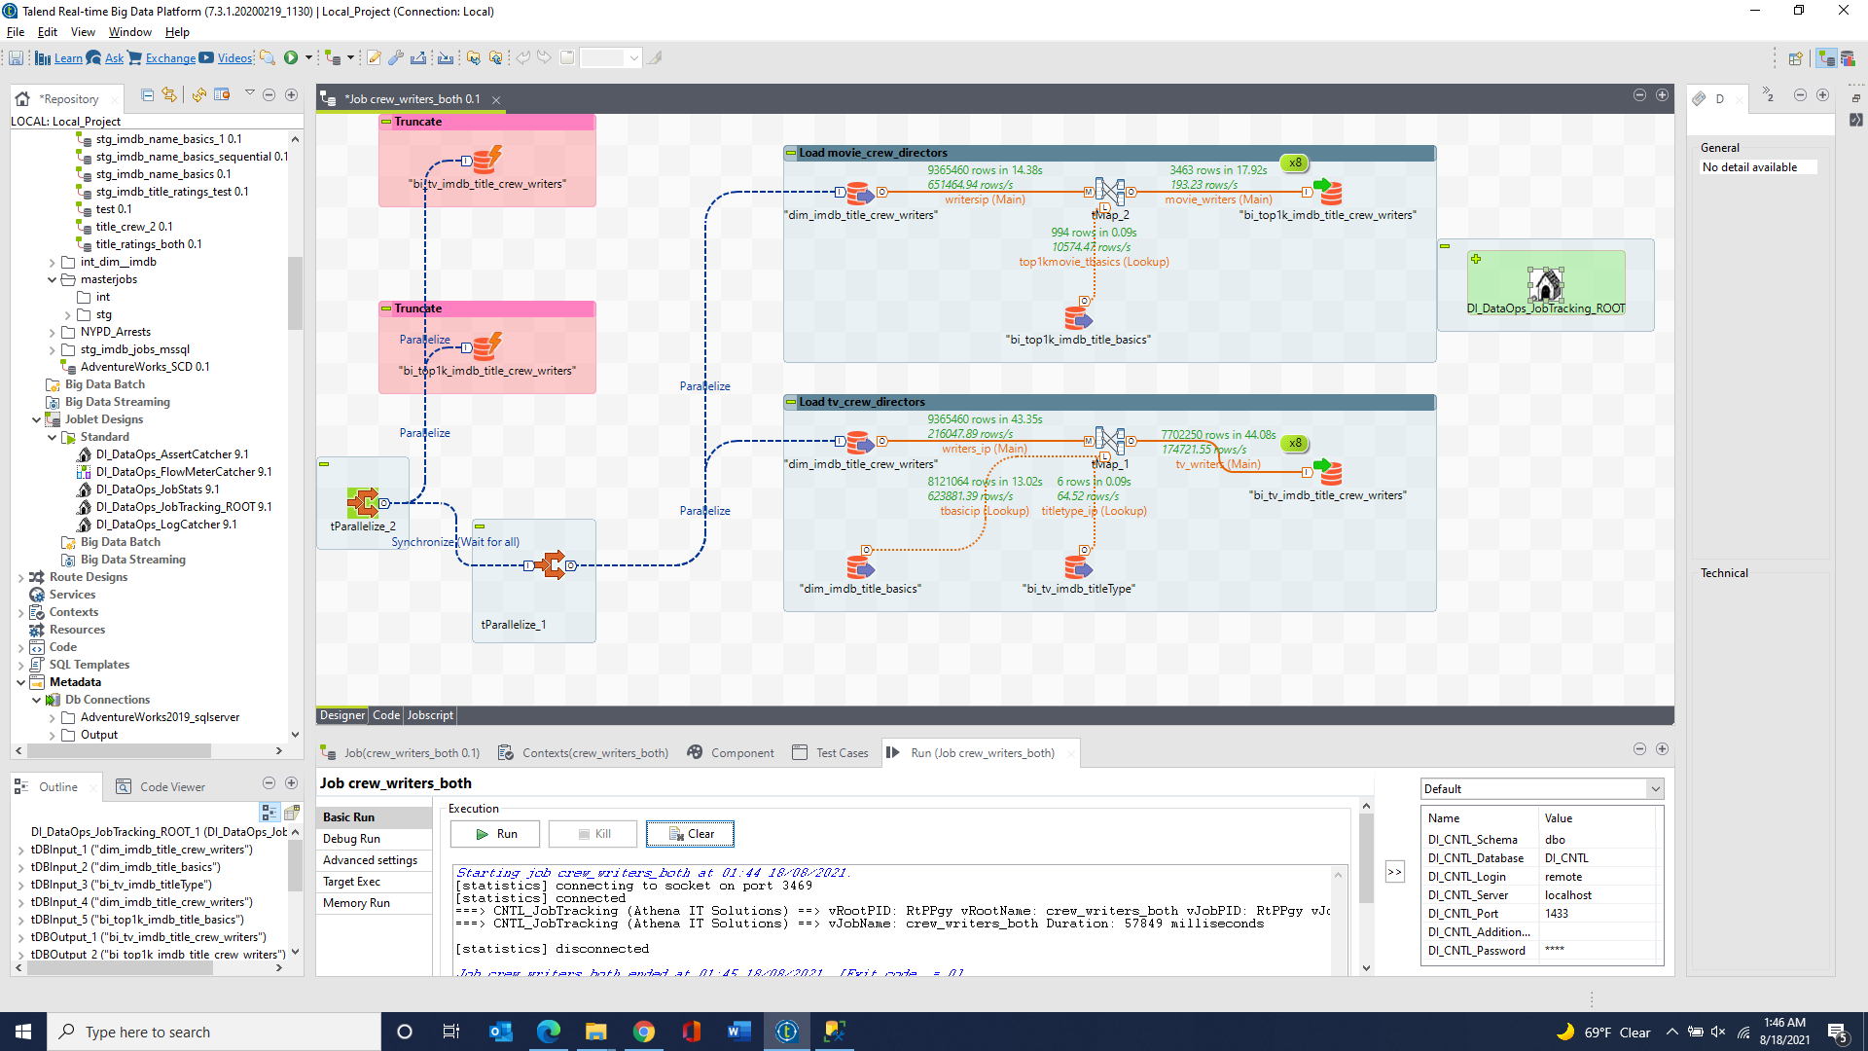

bi_tv_imdb_title_principals & bi_top1k_imdb_title_principals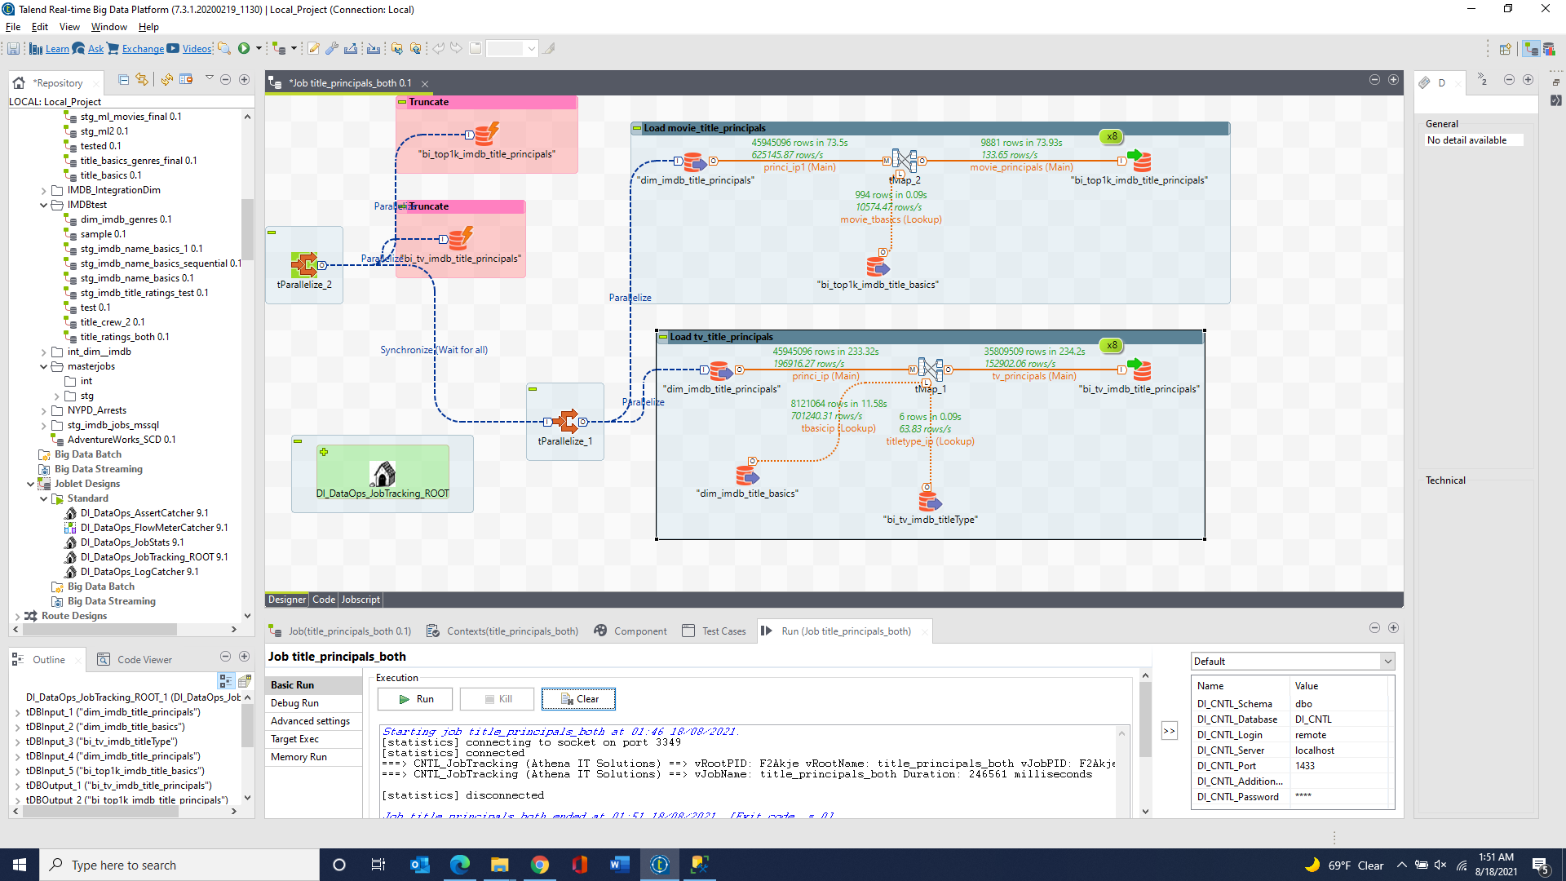

bi_tv_imdb_name_basics & bi_top1k_imdb_name_basics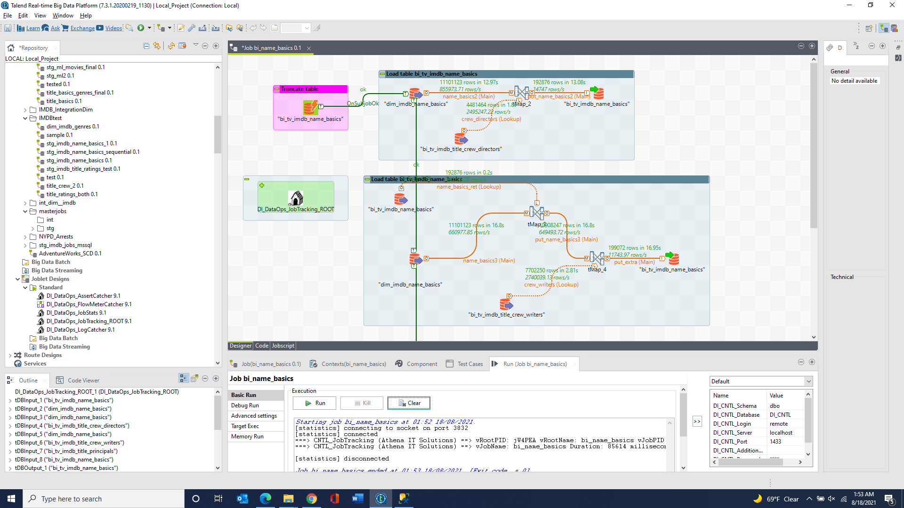 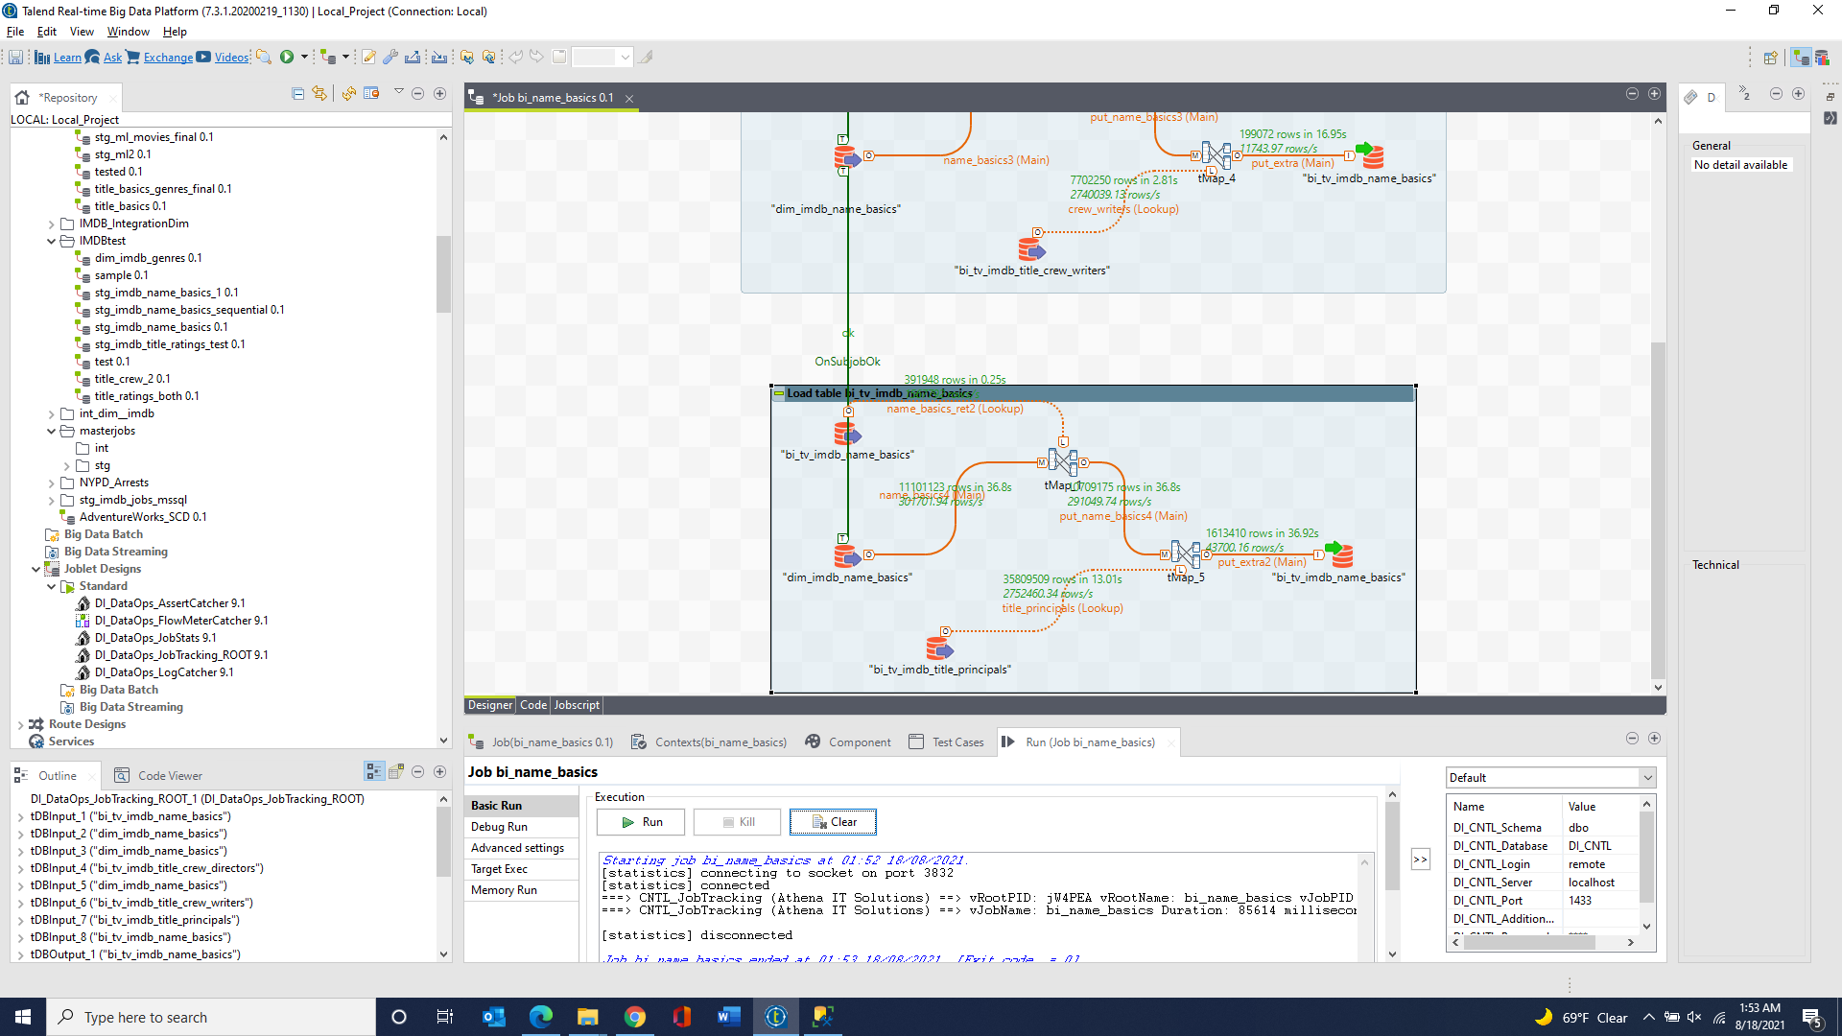

bi_tv_imdb_name_basics_knownForTitles 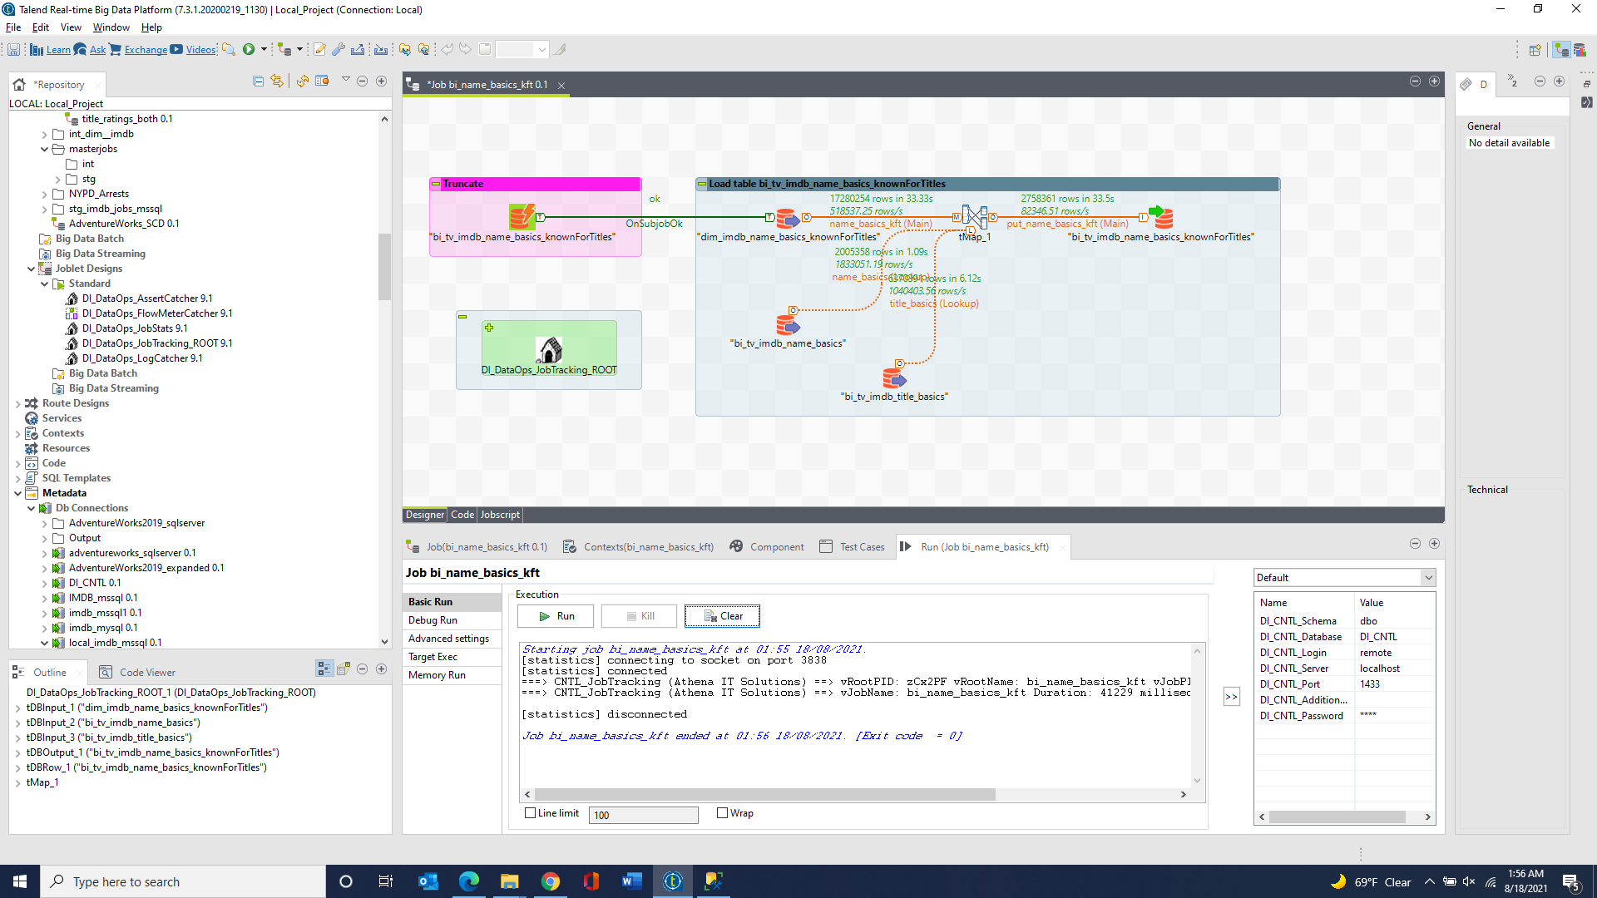

bi_tv_imdb_name_basics_primaryProfession 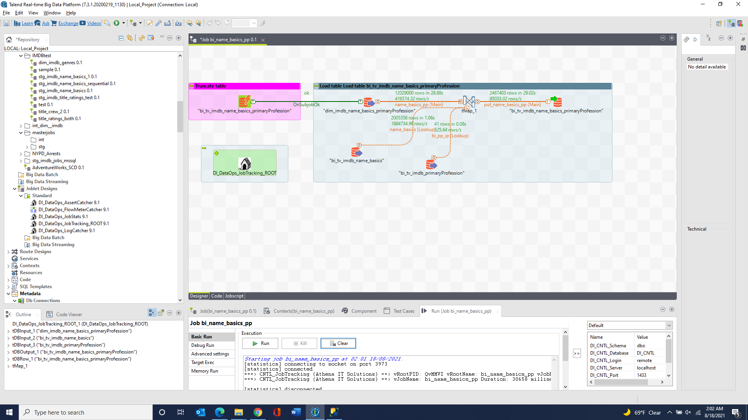

bi_tv_imdb_title_episode 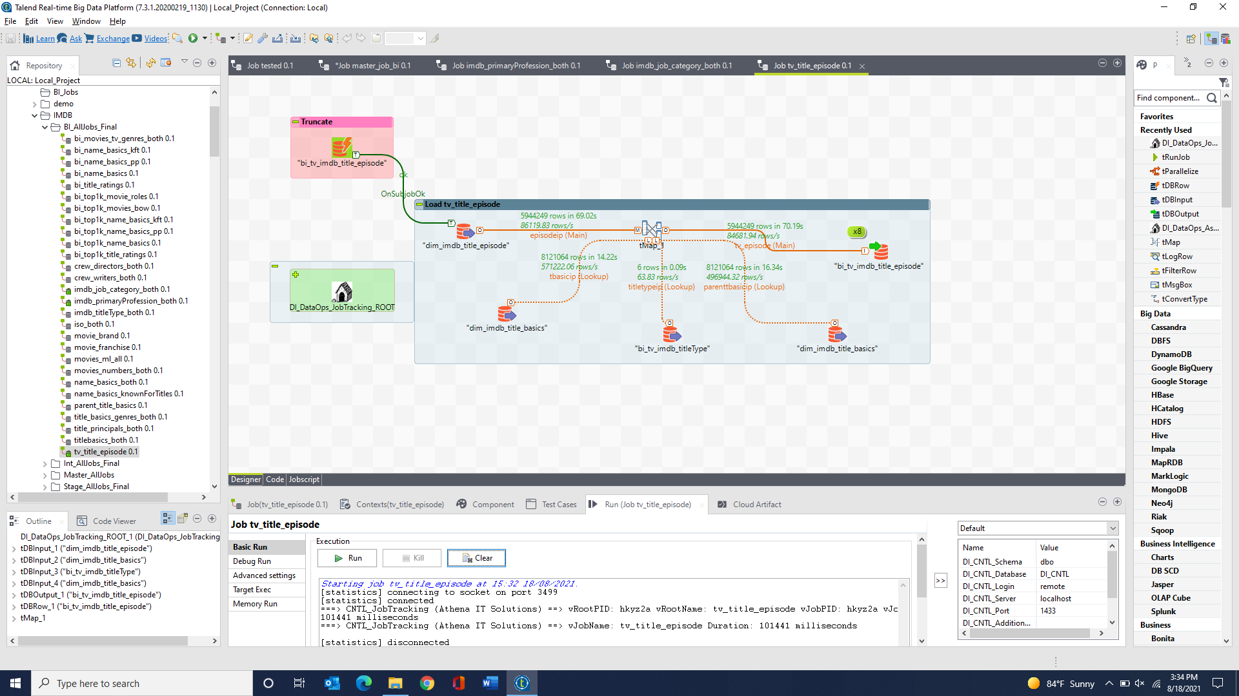

bi_tv_imdb_parent_title_basics 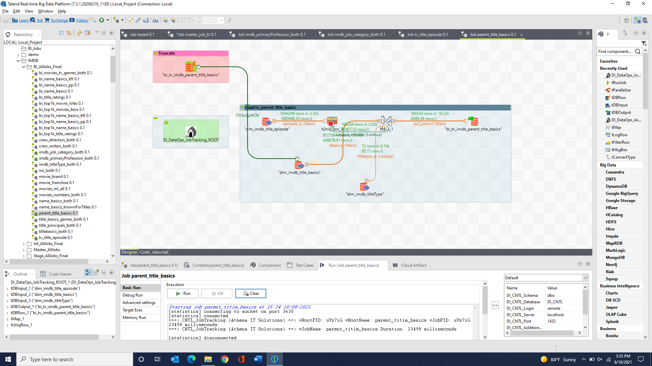

bi_top1k_movies_box_office_worldwide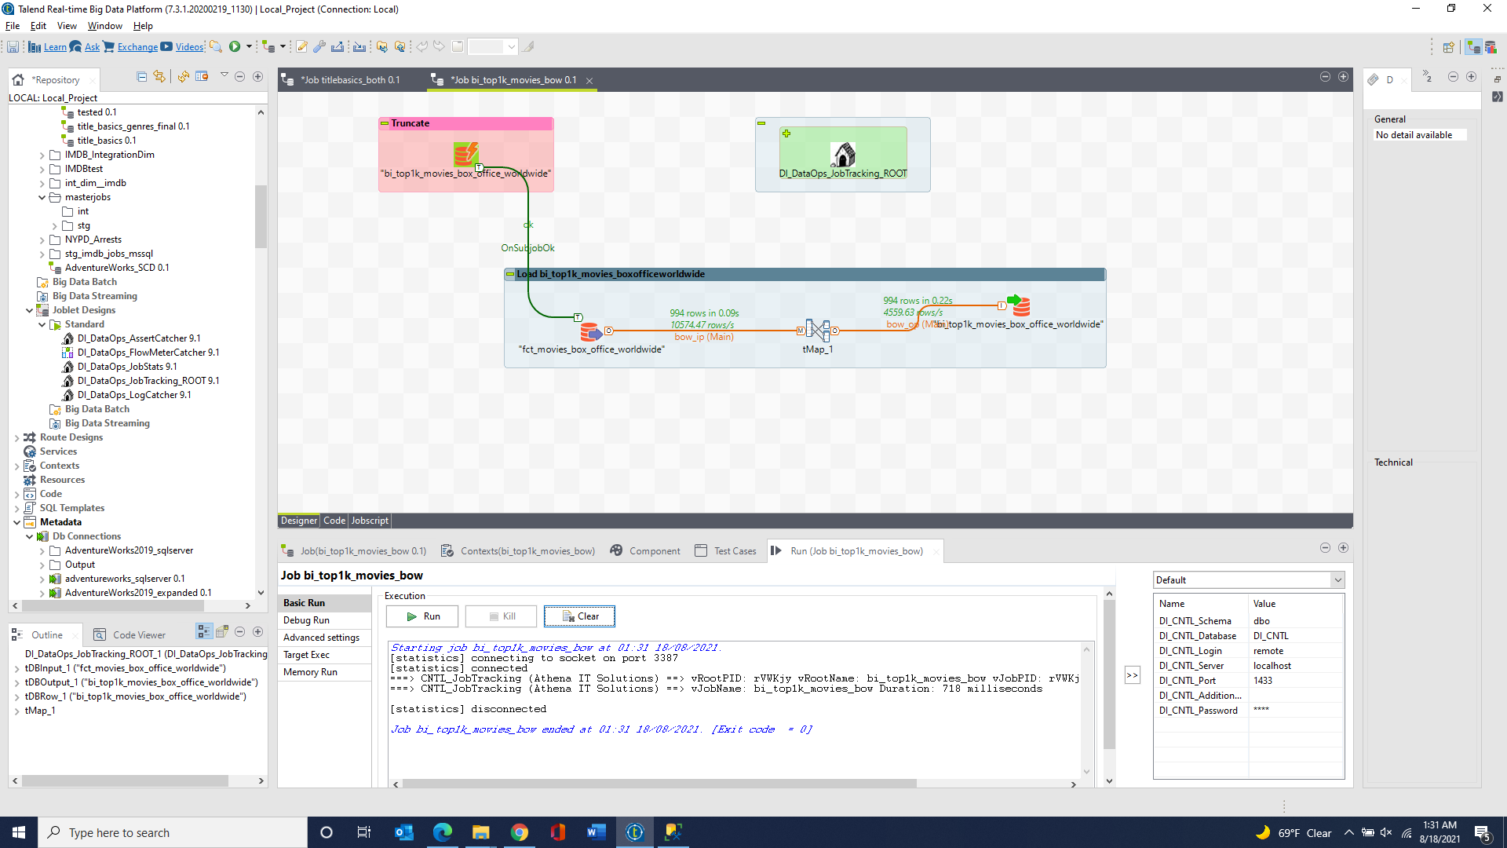

bi_top1k_imdb_title_ratings 

bi_top1k_imdb_name_basics_knownForTitles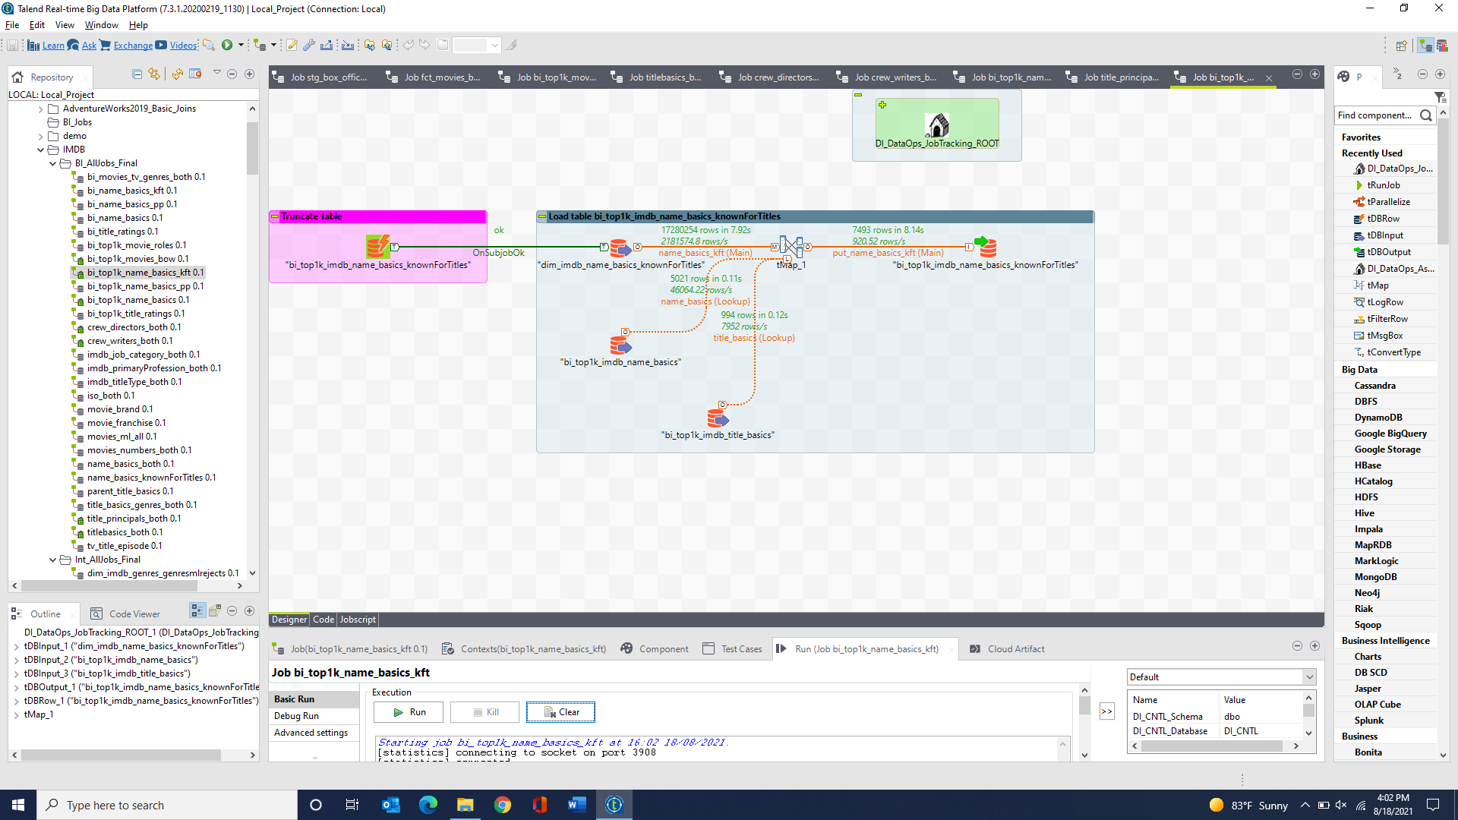

bi_top1k_imdb_name_basics_primaryProfession 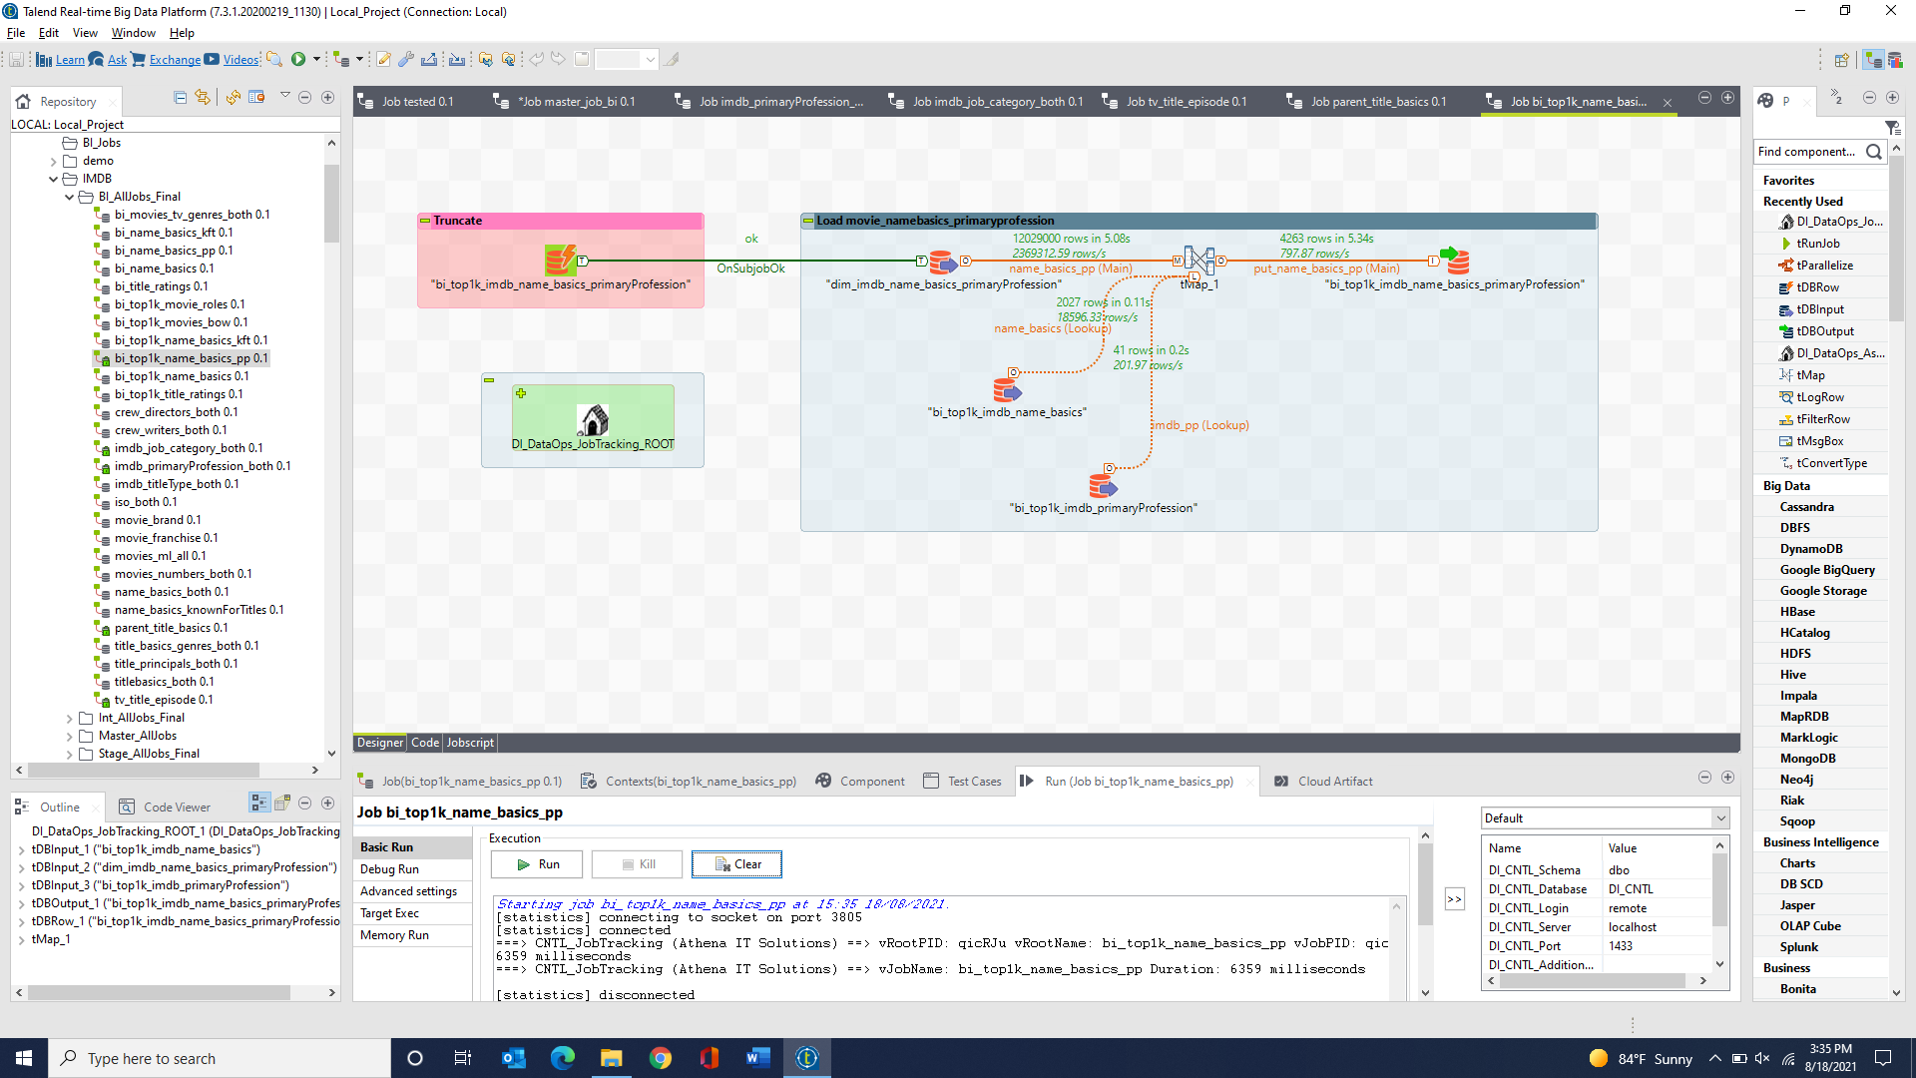

bi_top1k_imdb_movie_roles 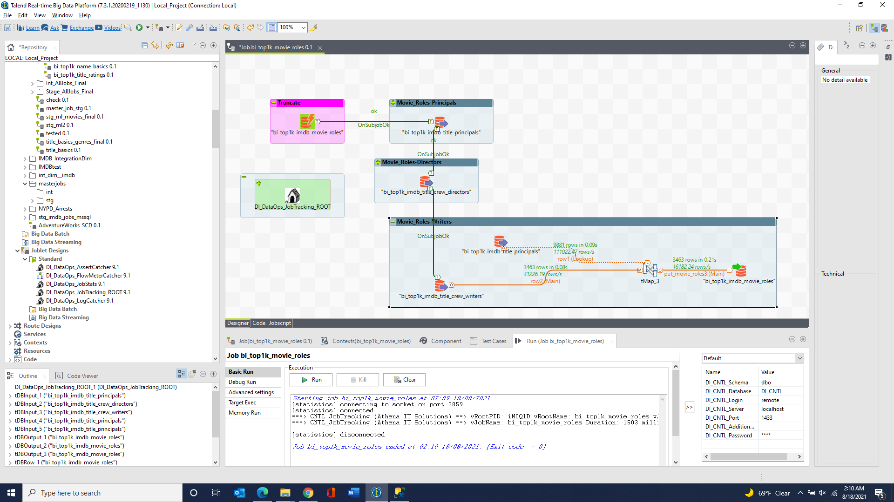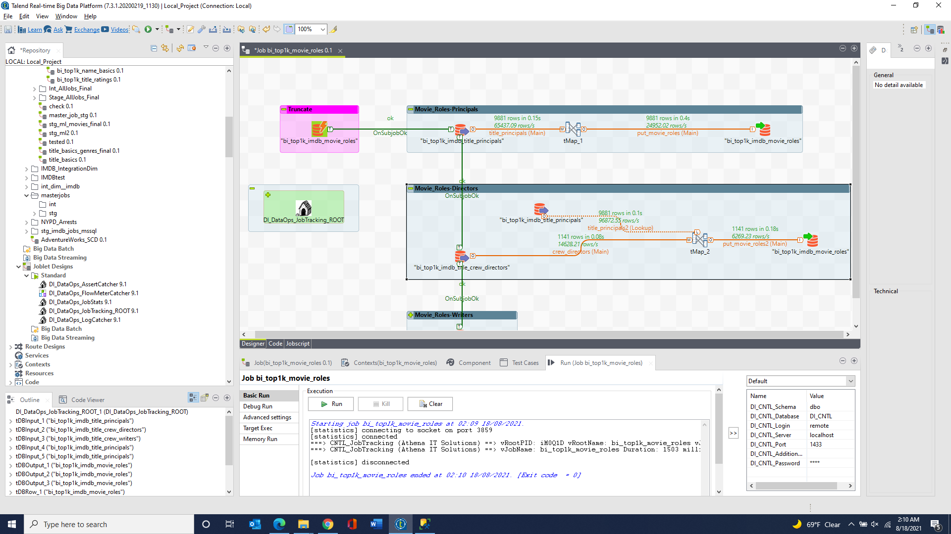

bi_top1k_imdb_Franchise & bi_top1k_imdb_franchises_gross & bi_top1k_imdb_franchises_list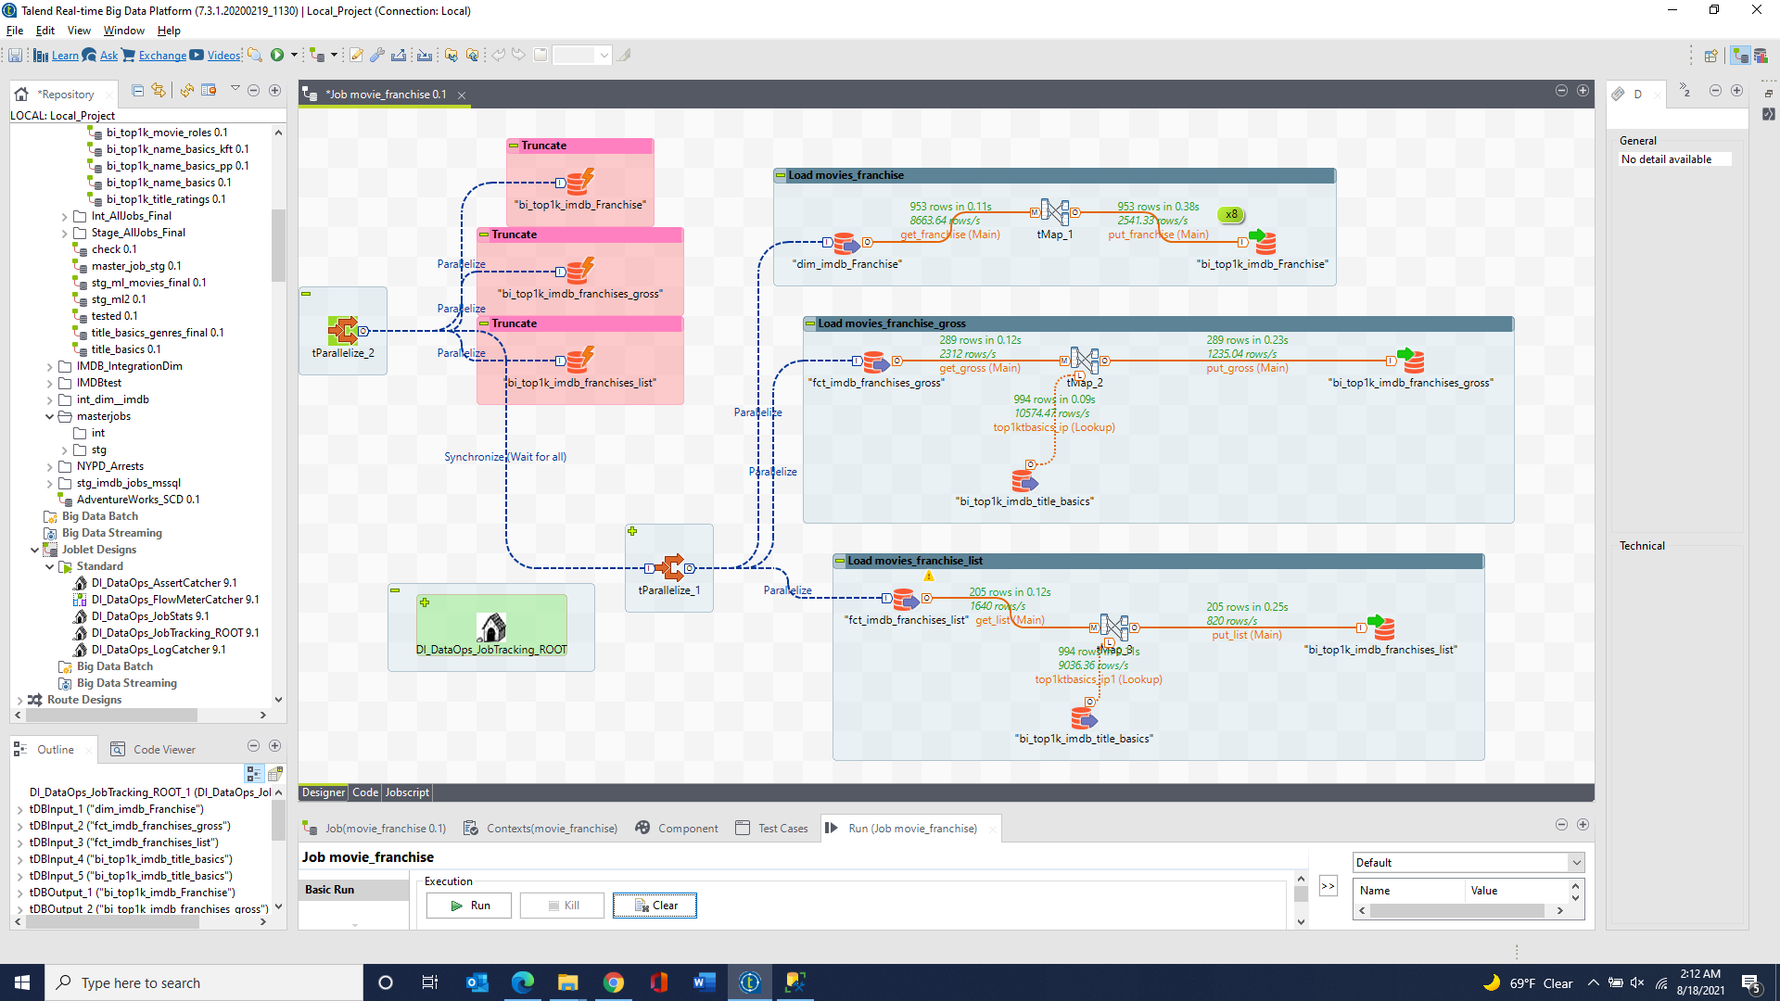

bi_top1k_imdb_brand & bi_top1k_imdb_brands_gross & bi_top1k_imdb_brands_list 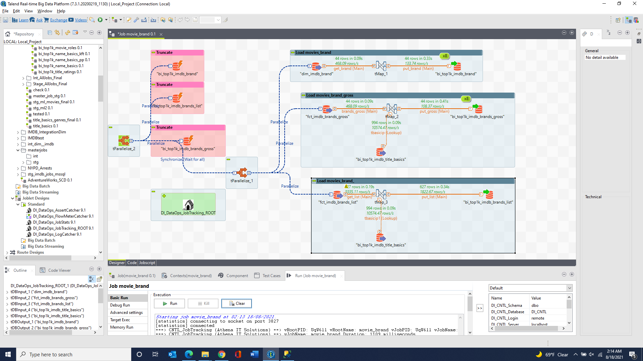

bi_top1k_numbers_daily_box_office & bi_top1k_numbers_franchise_all_box_office 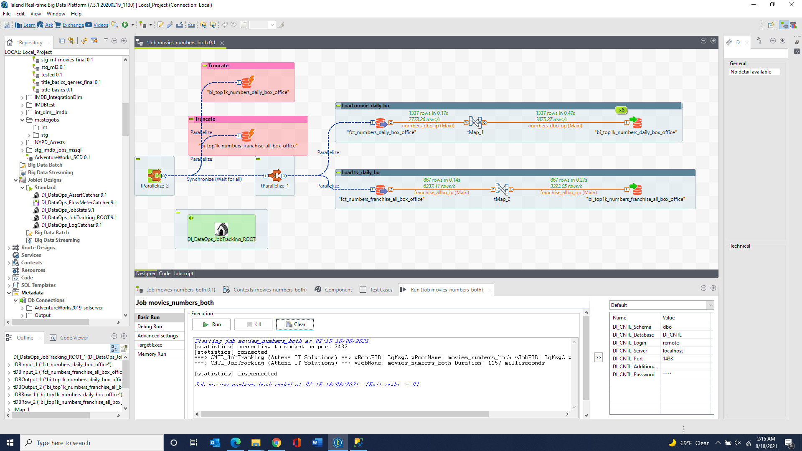

bi_top1k_ml_genome_scores & bi_top1k_ml_genome_tags & bi_top1k_ml_ratings & bi_top1k_ml_tags